Pokhara University

Level: Bachelor | Semester – Fall | Year : 2009
Programme: Be |  | Full Marks : 100
Course: Engineering Mathematics IV |  | Time : 3hrs.

Candidates are required to give their answers in their own words as far as practicable.
The figures in the margin indicate full marks.

Attempt all the questions.

1. | - Define harmonic function and its harmonic conjugate. Show that the function 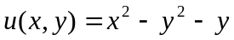is harmonic and find a harmonic conjugate v of u.  - State the Cauchy Integral formula and by using it evaluate the following integral: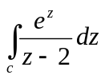  - C is a positively oriented circle |z| = 1  - C is a positively oriented circle |z-2| = 2 | 8  7
2. | - Find the Laurent series expansion of the function 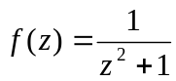about the point z = i and determine the precise region of convergence.  OR  State Cauchy residue theorem and then evaluate 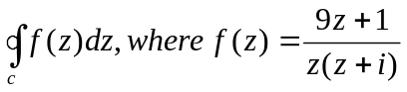and C is a positively oriented circle |z| = 2.  - Using the method of separation of variable solve the partial differential equation u_{xy} = -u_{x} | 8  7
3. | - Derive the one dimentional wave equation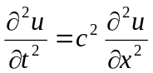.  - Find the deflection function u(x,t) of the string of length 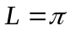 where c² = 1, the initial velocity is zero and the initial deflection is 0.01 sin3x.  OR  Show that the Laplacian in u in polar coordinate is 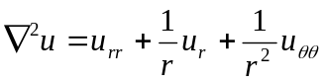. | 7  8
4. | - Show that 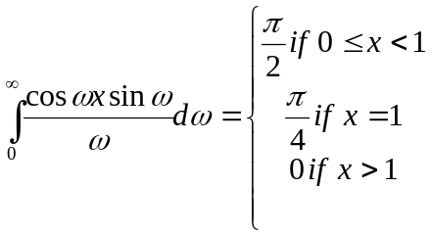  - Find the Fourier cosine transform of the function f(x) = e^{-ax} (a>0).  OR  Let f(x) be continuous and absolutely integrable on the x-axis, let f(x) be piecewise continuous on each finite interval and let f(x) tends to 0 as x tends to . Then 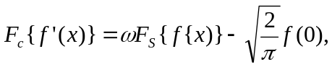where F_{S} and F_{C} denote the Fourier cosine and sine transform of the corresponding function. | 8  7
5. | - Maximize the function 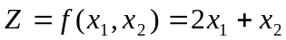subject to the conditions 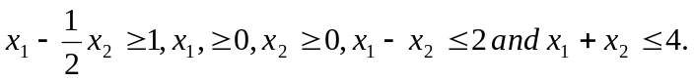  - Define Z-transform of a function f(t) and by using the definition find the Z- transform of (i) (-1)^{n} and (ii) n | 7  8
6. | - State the first shifting theorem for Z transformation and hence find Z[e^{-at}t].  - Find inverse Laplace transform of 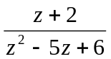  OR  Solve the difference equation | 7  8
7. | Answer the any five of the following questions.  - Find the principal argument of z = -2-3i.  - Write down the equation of the circle in complex form whose centre at i and of radius 1.  - If (x, y, z) and 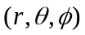are the coordinate of the same point in Cartesian and spherical polar coordinate form respectively. Write down the x, y and z in terms of 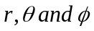.  - State the two dimensional wave equation in polar form.  - Show that where F_{c} stand for the Fourier cosine transform.  - Sketch the feasible region of the inequalities . | 2×5

